Wiki Link:
https://github.com/WyattMorgan20/GDP-Group-1-Balance---AI-Assisted-Bookkeeping/wiki

Project Information

Project Charter:
- Summary of the Problem: For accounting firms and CPAs, month-end close is a long and tedious process that is repeated on a monthly basis. Automating this could save firms a lot of time, effort and stress, allowing them to work on more important things.
- Motivation for solving it: To take away the repetitive, tedious and complicated month-end work.

About the developers:
- Owen Graham
  - Username: grahowe
  - Experience & Strengths
    - IoT/embedded programming - Arduino, ESP32, etc.
    - Programming Languages - Python, Swift, HTML/CSS
    - Programming troubleshooting and debugging
    - Web Mining
    - Webpage Development
    - Knowledge of Operating Systems - MacOS, Windows, Linux
  - Interests
    - Computer hardware
    - Electronics
    - Radio telecommunications

- Corey Unruh
  - Username: CUnruh641
  - Experience & Strengths
    - Programming in Python, Java, HTML/CSS, Javascript
    - Program troubleshooting/debugging
    - Development of Web Apps and Services
    - Web Mining
    - Database Systems
    - Data Structures
    - Problem solving
  - Interests
    - Website and video game coding
    - Learning and understanding computing topics

- Wyatt Morgan
  - Username: WyattMorgan20
  - Experience & Strengths
    - Coding in Java and Python
    - Object Oriented Programming
    - App Design Patterns & Frameworks
    - Web Mining
    - Data Visualization
    - Digital Media
    - Typography
    - Problem-solving
    - Creative
    - Leadership
  - Interests
    - Coding/creating video games
    - Graphic design

Problem Statement:
While tools like QuickBooks Online have streamlined many aspects of bookkeeping, the month-end close process remains a repetitive, manual, and time-consuming task for most companies. Despite being a critical financial activity performed every month, it is still largely handled using Excel spreadsheets with little automation or integration. This lack of efficiency not only increases the risk of human error but also delays reporting, consumes valuable staff time, and creates bottlenecks in financial operations as well as accountant communication.

Design:

Use Cases:

1. Account Creation
- Goal: Creating an Account
- Success Scenario Steps:
  - On system startup, login prompt appears
  - User clicks create account button on prompt
  - User enters desired username and password
  - User sets up Multi-Factor Authentication
  - User confirms entered credentials and clicks create account button
  - System creates the account
- Diagram:
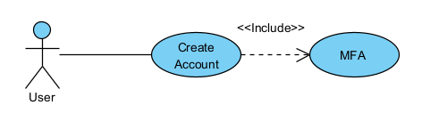

2. User Login
- Goal: Log In
- Success Scenario Steps:
  - On system startup, login prompt appears
  - After account creation, user is sent back to login prompt
  - User enters login information and clicks login button
  - User enter Multi-Factor Authentication credentials
  - System confirms credentials and logs user in
- Exceptions:
  - System confirms credentials and sends error: No matching user account
  - System confirms credentials and sends error: Incorrect credentials
- Diagrams:
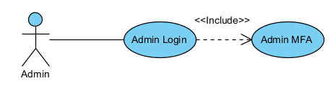 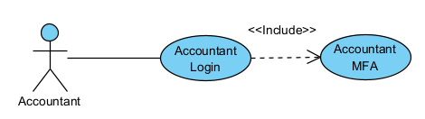 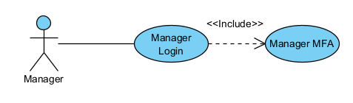 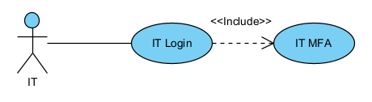

3. Manager Permissions
- Goal: Give Manager accounts proper Managerial permissions
- Success Scenario Steps:
  - After logging in, Manager is sent to Managerial dashboard
  - At the dashboard, Manager will:
    - See alerts for record deletion requests and final month-end close confirmation request for all current assigned bookkeeping projects
    - Get weekly report about updates to all current assigned bookkeeping projects
    - Receive ability to create, delete, and update all current assigned bookkeeping projects
    - See updates for accountants that have not updated books in two-day periods from assignments
    - Get notifications to review and approve reconciliations prepared by accountants
- Diagram:
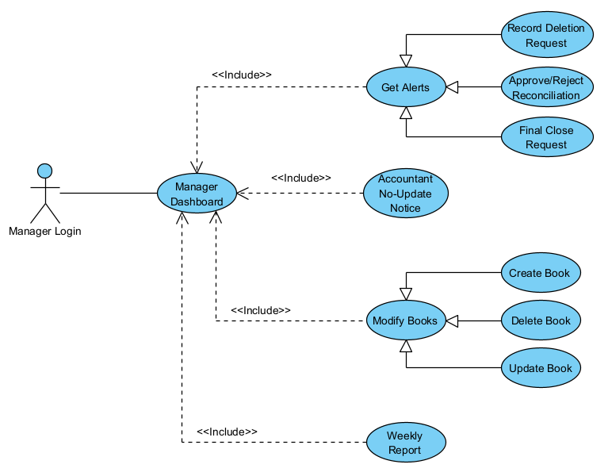

4. Accountant Permissions
- Goal: Give Accountant accounts proper Account permissions
- Success Scenario Steps:
  - After logging in, Accountant is sent to Accountants dashboard
  - At the dashboard, Accountant will:
    - Be able to add and update records in assigned bookkeeping projects
    - Have the ability to add supporting documents to assigned bookkeeping projects
    - Be able to view given task lists for assigned bookkeeping projects
    - Get the ability to prepare reconciliations
    - Receive notifications for review approval or rejection status from managers
    - Get read-only access to prior-period records for reference
- Diagram:
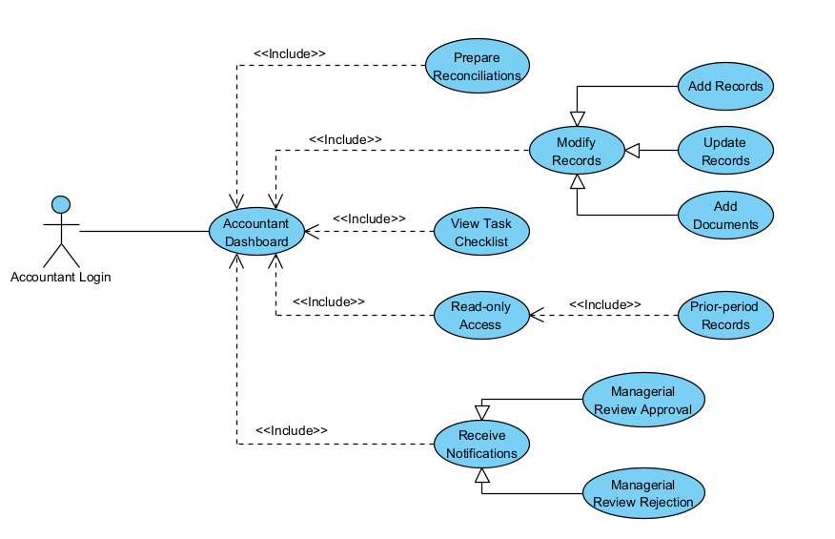

5. IT Permissions
- Goal: Give IT accounts proper IT permissions
- Success Scenario Steps:
  - After logging in, IT is sent to IT dashboard
  - At the dashboard, IT will:
    - Have the ability to create, modify and deactivate accounts that don't have the admin role
    - Be able to assign or revoke role-based access classes
    - Have the ability to manage authentication methods for users
    - Get the ability to see read-only copies of logs and audit trails
    - Have permissions to monitor system well-being(troubleshooting, errors, integrated software/systems)
- Diagram:
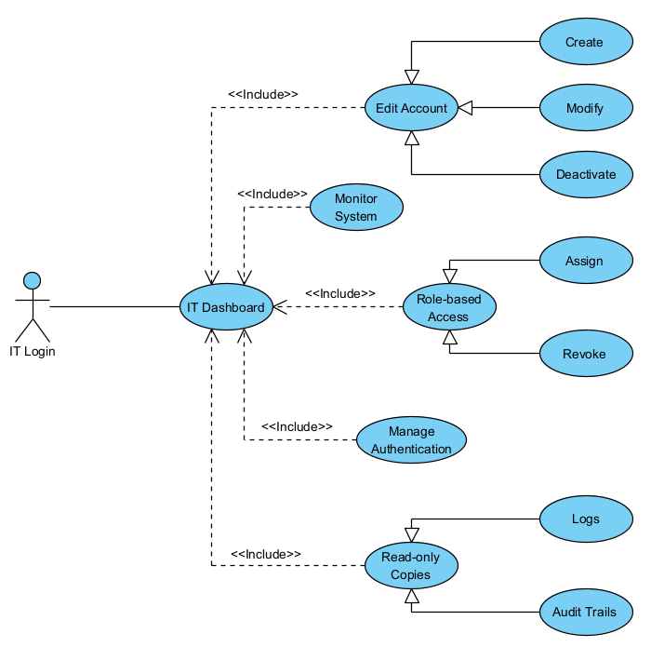

6. Audit Trail
- Goal: Allow respective users to see the audit trail for all transactions
- Success Scenario Steps:
  - After logging in, the user is sent to their respective dashboard
  - At the dashboard, the user will:
    - View timestamps for when a transaction is added to the books
    - View generated timestamps for when a transaction in the books is modified
    - Be able to open transactions to view their context
    - Click links to connected entries in opened transactions
    - View all timestamps for the transaction as a list inside the opened entry
- Diagram:
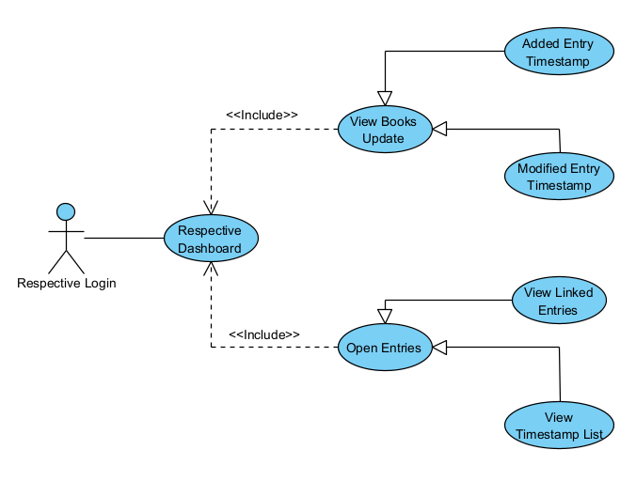

7. AI Integration
- Goal: Add AI to the system
- Success Scenario Steps:
  - After logging in, the user is sent to their respective dashboard
  - At dashboard, the user will be able to:
    - Use a chatbot AI assistant that works like an on-screen assistant for month-end close operations
    - View automatically-audited transaction links done by the built-in system AI
- Diagram:
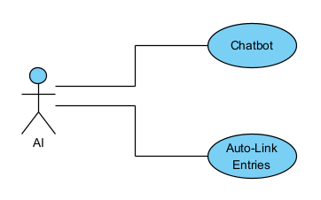

8. Data Management
- Goal: Manage data as efficiently and logical as possible.
- Success Steps:
  - After logging in, the user will be sent to their respective dashboard
  - To manage data, the user will have the following options:
    - Store information within a database (cloud-based)
    - Larger enterprises may need to use local storage for faster data access
    - Receipt scanning could be done using mobile features
- Diagram:
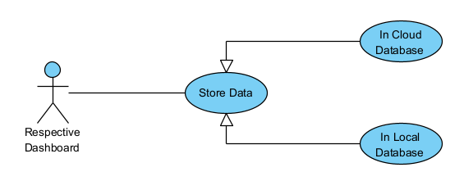

9. Bookkeeping Features
- Goal: Successfully prepare and generate records for bookkeeping and audit trails.
- Success Steps:
  - After logging in, the user will be sent to their respective dashboard
  - The user will generate data for audits based on the following options:
    - Auto-prepare bank reconciliation as the final product
    - Generate journal entries along with documents to support the entries
    - Show and highlight variances and anomalies to show any conflicting information
    - Generate Prepared By Client workflows for client interaction
    - Excel integration for exports and reporting
    - Supported input formats include .csv, .txt, and more common file types
    - Bank statements are included in audit trails
- Diagram:

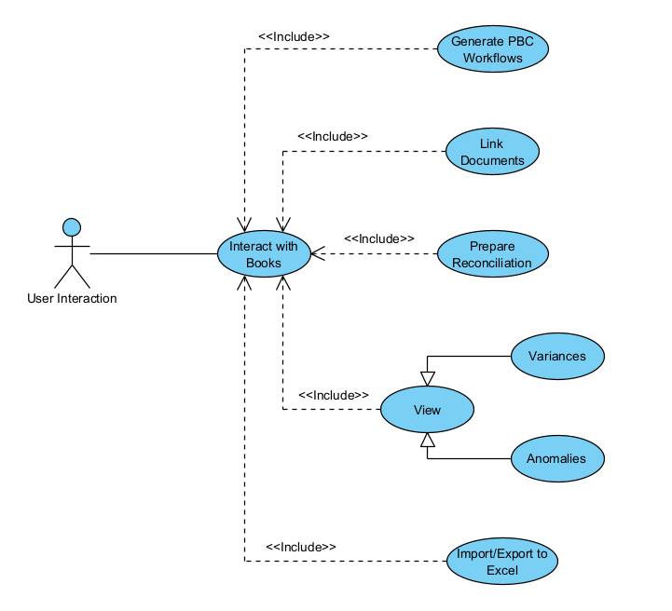

Functional Requirements:
1. Structure
- The system MUST allow businesses and organizations to build a simulation of how their company is structured.
- NOTE: Organizations/Businesses, Departments, Teams, Employees, Roles, etc.

2. Authentication & Security
- The system MUST have an account-based login system.
- The system MUST have different logins for different account types.
- The system MUST have Two-factor authentication (options: location-based, authenticator apps, etc.).
- The system MUST have IT/admin-level access for installs and troubleshooting.

3. Audit Trail Management
- The system MUST log who or what added or modified a transaction.
- The system MUST log timestamps for when a transaction is added to the books.
- The system MUST log timestamps for when a transaction in the books is modified.
- The system MUST allow transactions to be opened to view their context.
- The system MUST have links to connected entries in opened transactions.
- The system MUST store all timestamps for the transaction as a list inside the opened entry.
- The system MUST have links to connected documents and explain where the transaction is mentioned in opened transactions.
- NOTE: Documents can be Bank Statements, Journal Entries, etc.

4. AI Integration
- The system MAY have a chatbot AI assistant that works like an on-screen assistant for month-end close operations.
- If there is an AI, the AI MUST be open source so we don't have to worry about API calls and it can be run locally.
- The system MAY have a built-in system AI that will go through and automatically audit transaction links.

5. Data Management
- The system MUST filter the database so only that business or organization can access their data from it.
- The system MUST store information securely within a database.
- The system MUST prefer cloud database storage.
- The system SHOULD have local database storage for large enterprises.
- The system MAY have mobile features for receipt scanning.
- NOTE: Filter is just a figure of speech in this context. The database structure will create artificial divides in the data due to primary and foreign keys.
6. Bookkeeping Features
- The system MUST auto-prepare reconciliations for inputted documents.
- The system MUST highlight variances and anomalies between inputted documents.
- The system MUST provide Prepared By Client (PBC) workflows for easier client communication.
- The system MUST integrate with Excel, QBO, Xero for exports and reporting.
- The system MUST have .csv, .txt, etc. input formats.
- NOTE: Excel, QBO(QuickBooks Online) and Xero(read Zero) are some of the current tools used during month-end closes.

Non-Functional Requirements:
These requirements are recommended but are not strictly required for the project/system to run.
- The program should improve the efficiency of completing the problem. Month-end close operations should take no more than an hour.
- The program should improve the profitability of businesses/accounting firms by reducing the time accountants are working on the problem by at least 20%.
- The program should prioritize stability so that everything it can control is always accessible and online at least 95% of the time.
- The program should prioritize performance so that loading times are consistent based on network speed. Web pages should take no more than 5 seconds to open.
- The program should prioritize security for everything since it is dealing with monetary transactions for clients. Client data should be reliably safe and secure for those using our app.
- The program should prioritize usability so that non-technical users can handle it just as easily as technical users. The UI should be readable and comprehensive for just about everyone.
- The program should prioritize organization so that it remains uniform and appealing to look at for the average user.

Data Management Plan:

Important Data
- Data priority lies in robust data retention and auditability
- Names
- Timestamps
- Contact info
  - Phone numbers
  - Email address
- Receipts
  - Client-side: Keep screenshots
  - System-side: Extracted OCR/PDF format from screenshots for easier data collection
  - Digitized audit trails

ER Diagrams

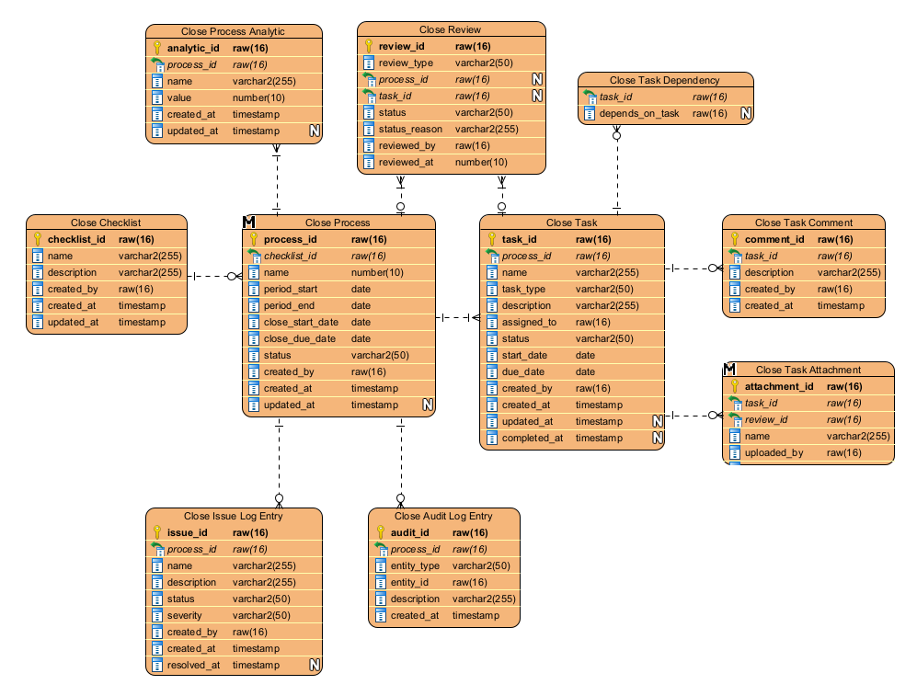

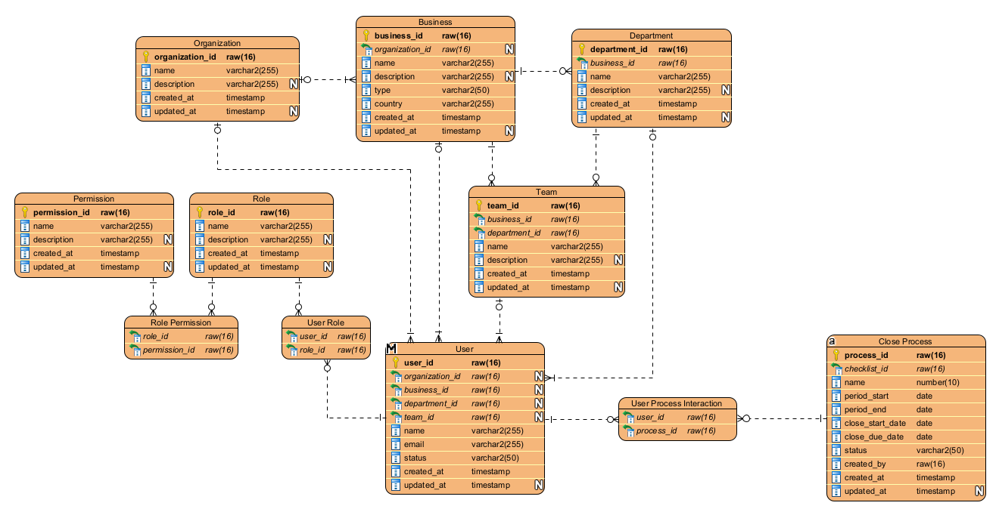
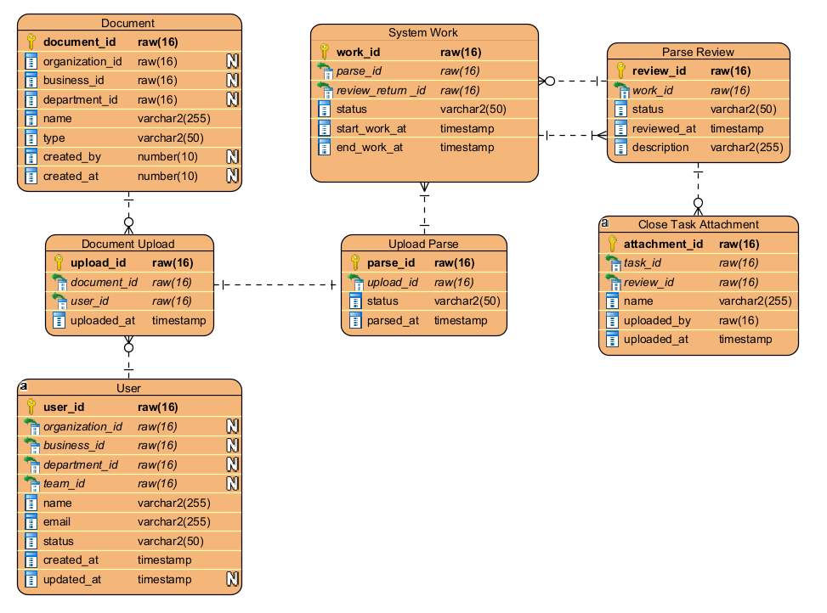

Data Security
- Data stored domestically
  - Prevents complexity of storing overseas/foreign
- Data deletion
  - Prevent deletion to preserve audit trails
  - Multi-factor deletion
  - Robust data retention - prevent accidental deletion, malicious deletion, etc.

Functional Requirements Mapping
Data will be shared and stored in a manner that corresponds to a user's permission level (admin, IT, etc.). The integrated AI may also have some form of permissions so that it can work with the data that is input and extracted, making the process more automated.

Notes
White N's on the diagrams stand for NULL, which means the fields can be blank.
Gold keys represent primary keys.
Green Arrows represent foreign keys.

List of Proposed Prototypes:

We want to get the following prototypes done by the end of this semester
- A website that:
  - Explains the pros and cons of the current system, our reason for creating the project (iteration 1)
  - Introduces the team, the developers that are making the project (iteration 1)
  - Has a spot to download the desktop application version of the project (iteration 1)
  - Gives a description of the features the project has (iteration 1)
  - Functions properly, so that you can navigate and view the information provided (iteration 1)
  - Is styled to look good and add visual aides for explaining the information provided (iteration 1)

We may be able to get the following prototypes done by the end of this semester
- Make the server code for running the website (iteration 1)
- Put together a basic application that can be downloaded from the website, then installed to the end-user's computer (iteration 1)

Meeting Minutes:
- Contents: All meeting minutes you have created so far

Meeting Minutes 0:
Date: August 27, 2025
Time: 9:00 AM
Location: Dr. Voss's Office

Attendees
- Wyatt Morgan – Project Manager / Developer
- Owen Graham – Documentation Handler / Developer
- Corey Unruh – Researcher / Developer
- Dr. Rob Voss – Client / Stakeholder

Meeting Agenda
- Understand project vision and target audience
- Discuss desired features and priorities
- Set deployment goals and timeline
- Plan research and next steps
- Establish communication expectations

Discussion Summary

Project Vision & Audience
- Target Audience: CPAs, accounting firms, and financial professionals
- Goal: Develop a full-stack bookkeeping platform
- Long-Term Plan: Expand into complete accounting software
- Deployment Goal: April 15, 2026 (align with tax deadlines)

Key Features & Requirements

AI Integration
- Voice-enabled chatbot assistant
- AI assists development but doesn’t replace coding entirely
- Potential tools: Gemini, Claude, ChatGPT, Eniden

Auditing & Transparency
- Users should be able to track money movement
- Maintain an audit trail for accountability

Frontend & UX
- “Amazing frontend” — clean, intuitive, responsive
- Good optics and simple usability prioritized
- Mobile-friendly if possible, but not required

Backend & Database
- No required language yet
- Database should remain lean and optimized
- Emphasis on providing clear, understandable data

Security & Stability
- System must be secure, reliable, and stable

Research & Planning

Timeline
- Research phase through mid-October 2025

Focus Areas
- Bookkeeping workflows and accountant expectations
- Competitor analysis — QuickBooks Online as a benchmark
- Database structure and backend design approaches
- Evaluating AI integration strategies

Tools & Resources
- Gemini (free for students)
- Claude, ChatGPT, Eniden, Flow, Suno, and other AI platforms

Q&A
Question | Asked By | Answer (Dr. Voss)
Who is the target audience? | Wyatt Morgan | CPAs, accounting firms, financial professionals
Is there a preferred tech stack? | Corey Unruh | No preference; prioritize security, speed, and UX
How important is mobile support? | Owen Graham | Not required, but useful if feasible
What’s the deployment timeline? | Wyatt Morgan | MVP ready by April 15, 2026
Should receipt processing be local or cloud-based? | Wyatt Morgan | Prefer server-side processing for better efficiency

Action Items

Research Phase (due by mid-October)
- Study bookkeeping workflows and client needs
- Analyze competitors like QuickBooks Online
- Draft potential database structures
- Explore AI integration strategies

Project Setup
- Create and configure shared GitHub repository
- Set up a reusable meeting agenda template

Prepare for Next Meeting
- Summarize research findings
- Propose initial high-level architecture ideas

Next Meeting
- Date: Wednesday, September 10, 2025
- Time: 8:30 AM
- Location: Dr. Voss's Office

Meeting Minutes 1:
Date: September 10, 2025
Time: Class Time
Location: Dr. Voss’s Office
Repository: GDP Group 1 Balance – AI-Assisted Bookkeeping

Attendees
- Wyatt Morgan – Project Manager / Developer
- Owen Graham – Documentation Handler / Developer
- Corey Unruh – Researcher / Developer
- Dr. Rob Voss – Client / Stakeholder

Meeting Agenda
- Review core project requirements
- Define functional and non-functional requirements
- Discuss trustworthiness, auditing, and compliance
- Explore potential storage options and cost factors
- Determine next steps and deliverables

Discussion Summary

1. Trustworthiness & Auditability
- System outputs must be accurate and reliable.
- Must maintain audit trails:
  - Track who performed actions and when.
  - Support full traceability of financial data changes.
- Auditability emphasized as a core system requirement.

2. Users & Roles
Primary Users:
- Business owners
- Bookkeepers
- Accountants
Account Levels:
- Owner Account → Full access and control.
- Auditor / Manager Account → View with limited edit permissions.
- Junior Employee Account → Minimal permissions for basic tasks.

3. Potential Research Topics
- Understand financial terminology and workflows.
- Evaluate storage options:
  - Local database preferred for direct control.
  - Cloud storage possible if needed.
  - Compare price, usability, locality, and security.
  - Possible UI integration - WhisperFlow --> ChatGPT
  - Processing power needed for tasks
- Review competitors:
  - QuickBooks Online
  - Xero
  - Other AI-assisted bookkeeping tools.

4. Functional Requirements

Authentication & Security
- Account-based login system with tiered permissions.
- Two-factor authentication (options: location-based, authenticator apps, etc.).
- IT/admin-level access for installs and troubleshooting.

Audit Trail Management
- Timestamps for all entries and modifications.
- Link related transactions for easier auditing.

AI Integration
- Conversational AI assistant to interpret user intent.
- Tools under review: Gemini, Claude, ChatGPT, and others.

User Interface & Experience
- Responsive dashboard for month-end close workflows.
- Clean, simple, and intuitive design.

Data Management
- Store information securely within a database.
- Prefer local storage but allow cloud options if needed.
- Explore mobile features for receipt scanning if time allows.

Bookkeeping Features
- Auto-prepare bank reconciliation records.
- Generate journal entries with supporting documents.
- Highlight variances and anomalies.
- Provide Prepared By Client (PBC) workflows for easier client communication.
- Integrate with Excel for exports and reporting.

5. Non-Functional Requirements
- Accessible for non-technical users.
- Must improve:
  - Efficiency (time savings)
  - Profitability (help clients save or earn money)
- Prioritize stability, performance, and security.

Q&A
Question | Asked By | Answer (Dr. Voss)
How accurate must the system’s outputs be? | Wyatt Morgan | Must be 100% trustworthy to support financial decisions.
How would you prefer we handle storage? | Corey Unruh | Local preferred for control, but cloud may be used if cost-effective.
Should we add mobile support? | Corey Unruh | Not required, but receipt scanning would be valuable.
What are major apps currently used by companies? | Wyatt Morgan | QuickBooks Online and Xero are primary benchmarks.
Authentication expectations? | Wyatt Morgan | Multi-level permissions with two-factor authentication are mandatory.

Action Items

Research
- Compare local vs. cloud storage options.
- Review competitors (QuickBooks Online, Xero).
- Explore AI tools for integration.

Design
- Draft high-level system architecture.
- Create UI/UX wireframes for dashboard and authentication flows.

Deliverables for Next Meeting
- Database structure proposal.
- Dashboard mockup.
- Competitor analysis summary.

Next Meeting
Date: Wednesday, September 24, 2025 (tentative)
Time: Class Time
Location: Dr. Voss’s Office

Meeting Minutes 2:
Date: September 24, 2025
Time: Class Time
Location: Dr. Voss’s Office
Repository: GDP Group 1 Balance – AI-Assisted Bookkeeping

Attendees
- Wyatt Morgan – Project Manager / Developer
- Owen Graham – Documentation Handler / Developer
- Corey Unruh – Researcher / Developer
- Dr. Rob Voss – Client / Stakeholder

Meeting Agenda
- Application scale (enterprise-level expectations)
- Storage/database strategies
- Documentation requirements and user guidance
- Helper chatbot integration possibilities
- Planning tools and naming options

Discussion Summary

1. Application Scale & Vision
- Enterprise-grade focus.
- End result and time and money savings prioritized over process.
- Aim for an “aha” user moment.
- Use empty space to drive value.
- First step: Login page with clear information.

2. Database & Storage
- Options: cloud, local, or hybrid.
- On-site storage may be required for large enterprises.
- Cloud-first recommended for accessibility and control.
- Action item: research responsible financial data storage (domestic vs. foreign).

3. Documentation & Data Input
- Input formats: .csv, .txt, etc.
- Audit trail must include bank statements (PDFs).
- Documentation style: clean, simple, natural flow.
- Instructions: concise, clear, user-friendly, with support for correcting mistakes.

4. Helper Chatbot
- Potential on-screen assistant for month-end close support.
- Could be a basic text window interface.
- Build vs. integrate existing solutions.
- Considered future/endgame feature, not immediate.

5. Planning Tools & Future Work
- Begin central planning document (include Dr. Voss).
- Explore Notion for project management.
- Brainstorm product names and check domains via ICANN and whois.
  - Examples: Balance, Balanced.

Q&A
Q (Wyatt Morgan): What should the product scale toward?
A (Dr. Voss): Think enterprise-size, with scalability in mind.
Q (Corey Unruh): Should we focus more on cloud or local storage?
A (Dr. Voss): Cloud-first, but local may be needed for enterprise-grade storage.
Q (Owen Graham): How should documentation be structured?
A (Dr. Voss): Keep it simple, clear, and natural.
Q (Wyatt Morgan): Should chatbot integration be immediate?
A (Dr. Voss): Not required now — target it as a future feature.

Action Items
- Research storage recommendations (cloud vs. local vs. hybrid, financial data compliance).
- Draft login page design and documentation flow.
- Set up Notion project space for centralized planning.
- Begin name brainstorming and check domain availability.

Next Meeting
Date: Wednesday, October 8, 2025 (tentative)
Time: Class Time
Location: Dr. Voss’s Office

Meeting Minutes 3:
Date: October 8th, 2025
Time: Class Time
Location: Dr. Voss’s Office
Repository: GDP Group 1 Balance – AI-Assisted Bookkeeping

Who Was Present
- Wyatt Morgan – Project Manager / Developer
- Owen Graham – Documentation Handler / Developer
- Corey Unruh – Researcher / Developer
- Dr. Rob Voss – Client / Stakeholder

Meeting Agenda
- Domestic vs. Foreign data storage
- Domain name discussion (balanced.com)
- Review Non-Functional Requirements
- Review data management plan
- Ask about progress with finance contact
- Set project goals for next meeting

Discussion Summary
- Domestic vs. Foreign Data Storage
  - System will be primarily U.S.-based.
  - Foreign accounting introduces complexity and “messiness.”
- Data Management Plan
  - Must prioritize auditability and robust data retention.
  - Include names, timestamps, contact info, and receipts.
  - Clients retain receipt images; system stores extracted data only.
  - Restrict data deletion to preserve audit trails.
- Non-Functional Requirements
  - Usability is the core focus (major marketing angle).
  - Emphasize speed, transparency, and modern UI.
  - Provide clear system feedback (loading, output, etc.).
  - Ensure security and data reliability.
- Future Goals
  - Explore integration into accountancy workflows.
  - Research month-end close, accountant needs, and edge cases (car sales, investment accounts).

Specific Questions Asked
- Wyatt: Should we prioritize domestic or foreign data storage?
- Owen: What controls are required for data access and deletion?
- Corey: Any updates on the finance professional consultation?
- Wyatt: Which non-functional requirements are top priority?
- Owen: How should receipt data be managed?
- Corey: Should a helper chatbot be considered in this phase?

Specific Answers Given
- Dr. Voss: Data should remain domestic (U.S.).
- Dr. Voss: No data deletions should occur without full traceability.
- Dr. Voss: He plans to follow up with the finance contact.
- Dr. Voss: Prioritize usability, security, and transparent feedback.
- Dr. Voss: Clients hold receipt images; system stores only parsed data.
- Dr. Voss: Chatbot feature is a future enhancement, not current priority.

Action Items
- Wyatt: Research storage solutions (domestic vs. cloud hybrid).
- Owen: Document auditability and access policies.
- Corey: Research accounting workflows and month-end close processes.
- Team: Refine non-functional requirement list (usability, transparency).
- Team: Brainstorm names; check domain availability (balanced.com).
- Team: Develop a data management UI mockup for review next meeting.

Next Meeting
Date: Wednesday, October 22nd, 2025 (tentative)
Time: Class Time
Location: Dr. Voss’s Office

Meeting Minutes 4:
Date: October 29th, 2025
Time: Class Time
Location: Dr. Voss’s Office
Repository: GDP Group 1 Balance – AI-Assisted Bookkeeping

Who Was Present
- Wyatt Morgan – Project Manager / Developer
- Owen Graham – Documentation Handler / Developer
- Corey Unruh – Researcher / Developer
- Dr. Rob Voss – Client / Stakeholder

Meeting Agenda
- Discuss functional requirements for iteration 3
- Talk about seed data assignment
- Data management plan amendments
- App structure ideas(multi-page sit + database, single-page site + database, single-page site + database + desktop app)
- Ask about progress with finance contact
- Set project goals for next meeting

Seed Data
- Keep it simple
  - Smallest usable set
  - Not talking about inventory
  - Sole proprietor
    - Checking account data
    - Doesn’t include data for odd events
    - Not talking about edge cases, but center data
- Use ChatGPT, feed it a created Excel file and have it populate it with the necessary data

Functional Requirements
- For AI Integration
  - Open source so we can run it locally and not worry about API calls
  - Not fast, but effective
- Bookkeeping Features
  - The functions for the end user
- The login piece (connection piece) is the most important

App Structure
- If we want to leverage AI and keep it cheap
  - Run it locally
  - Security
- If that isn’t an issue, to make it more accessible to users:
  - Make it remote and use API calls to run it off an AI program
- Make it look like a webpage as a desktop app
  - Potential different installs with different departments
    - Logins will need to have a handshake to make sure the data is the same
- Small business focused – local install
- Company - Block
  - Goose
    - Coding agent
    - Grant program (?)
      - Wish List
  - Financial-focused company
- Lenny’s Podcast

Next meeting
- Wish list - anything that would help us advance and develop the project
- Look into Goose - AI coding assistance on GitHub
- What pieces of this project could be open source
- Send meeting agenda to robvoss.com
- Next meeting
  - Wednesday, November 12th
  - Dr. Voss’s Office
  - 8:45-9:50

Meeting Minutes 5:
Date: November 12th, 2025
Time: Class Time
Location: Dr. Voss’s Office
Repository: GDP Group 1 Balance – AI-Assisted Bookkeeping

Who Was Present
- Wyatt Morgan – Project Manager / Developer
- Corey Unruh – Researcher / Developer
- Dr. Rob Voss – Client / Stakeholder

Meeting Agenda
- Talk about progress on project structure
- Talk about next meeting possibilities
- Show progress with site
- Discuss any ideas for site style/looks
- Discuss ideas for site sections
- Ask about progress with finance contact OR mentioned meeting from last time
- Set project goals for next meeting

- It’s about the approach
  - Not about the tool
  - But the problem we are trying to solve for the client
    - I.e. “if you’re a business trying to look for accountants for month end closing, click here”
- Go AI-powered
  - No API calls for the program to work
  - Claude Code
- Agents
  - Create security agents for security
- Played with some logo ideas
- ColorHex
  - Gives specific color ratings
- Goals for next meeting
  - General website design
    - Make it work
    - MAYBE screenshots for what the app will look like
  - General dashboard with placeholders FOR APP
    - Just the structure
    - Pull in user info (log in & accounts)

